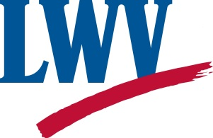 | Insert LWV Name  Insert LWV Address & Contact Information

DRAFT DRAFT DRAFT DRAFT

Dear :[Insert name]

Now more than ever, Americans are hungry for information that is factual, free of partisanship and propaganda. Because of the League’s reputation for empowering voters with nonpartisan information, we are increasingly being called upon to comment on a wide range of issues related to good government. And we need your help to answer that call.

Since the 2016 Presidential election and 2018 Midterm election, LWV of [Name of LWV] has received more inquiries about our services than at any other time in our history. Below are a few of the efforts started this year to meet the increased demand for League services.
- Name of Voter Outreach campaign. Briefly explain voter outreach program and the need to do more.
- Name Voter Education work or campaign. Briefly explain the work and the need to expand or maintain the critical program.
- Advocacy work or campaign. Briefly explain work to protect voters, or other work.
- Get Out the Vote. Briefly explain GOTV activities and how many voters the League’s work will help.
This is just the beginning. In the next year as we celebrate our multiple 100th anniversaries: the 19th Amendment (8/18/1920), the formation of LWVUS (2/14/1920) and our own [Name state] league (list date), our goal and mission is simple: 100%. 100% voter registration and 100% turnout. Too optimistic? With your help it’s possible. It’s clear that LWV of [Name of League] still has work to do, there are still many underserved areas in [Name state/local area] where we need to ensure that every eligible voter is registered and has the knowledge and the opportunity to vote.

[[Insert how much $ needed to keep vital programs running.]] Please give generously.

